***ShopNest***

***ShopNest Store Capstone Project Analysis:***

**Introduction:**

According to the data received, ShopNest is an e-Commerce Marketplace, and the data for analysis consisted of 9 different data tables.

To understand the data set please find below the data relationship model:

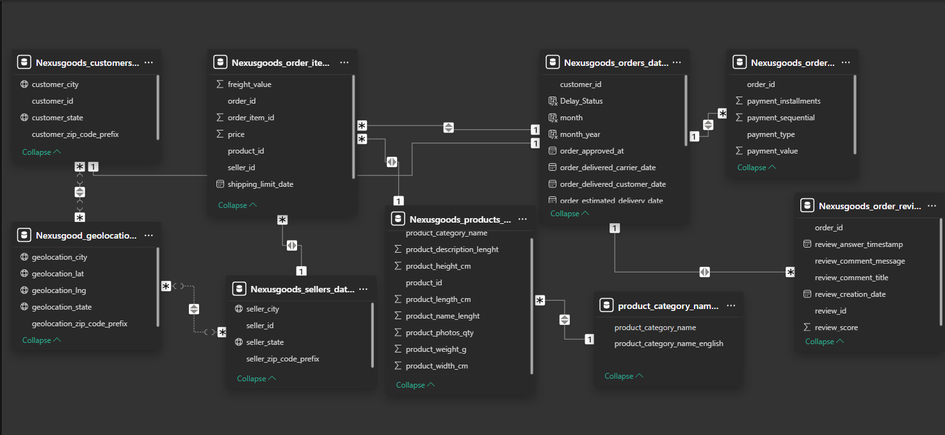

Table refers to the custom table created for analysis purpose.

It is understandable from the questions that the main focus is on understanding the operational efficiency. Please find the explanation for each questions as under.

**Dashboard:**

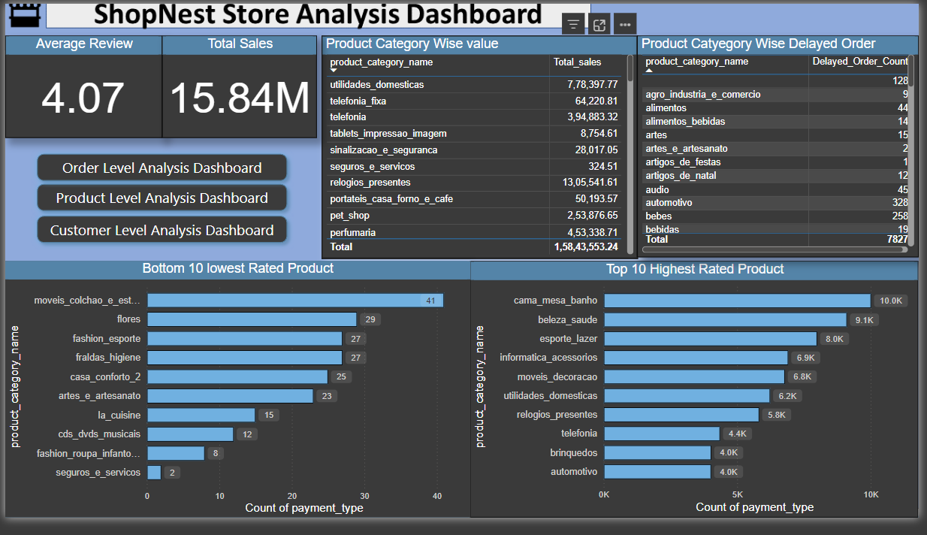

*Img* 1.

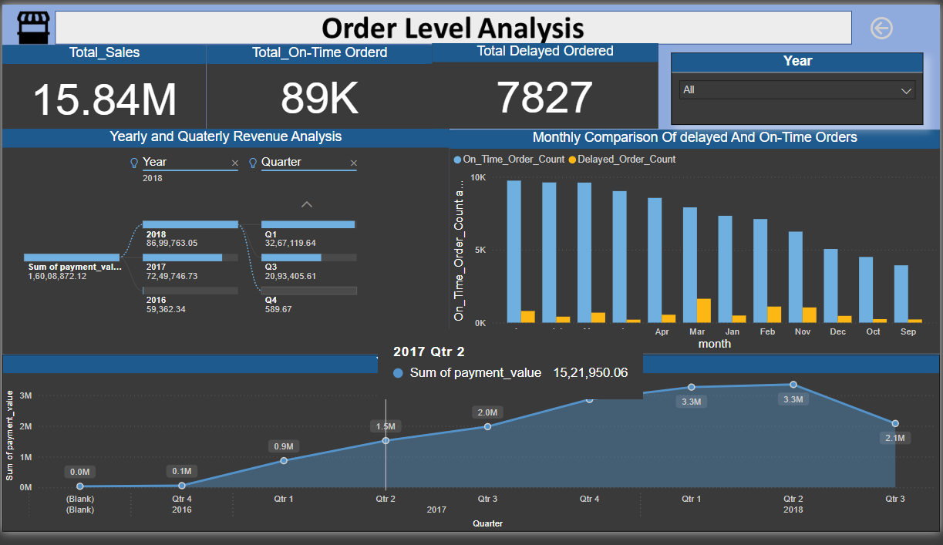

*Img* 2

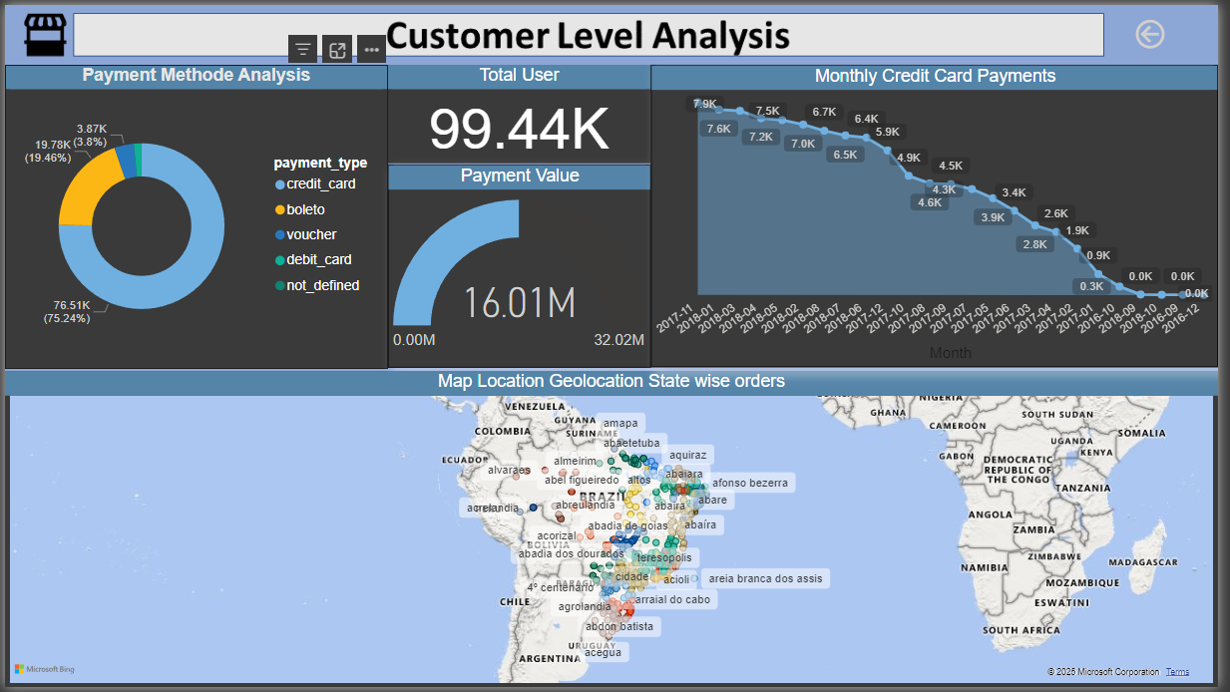

*Img* 3.

Explanations for the questions are as follows:

**Q.1** Identify and visually represent the top 10 product categories by total sales.

**Top Categories by Total Price:-**

**Key Insight:** The top-performing product category by total sales is "utilidades_domesticas", with total sales of 7.78M, followed by "telefonia_fixa" and "telefonia".

**Visualization:** A bar chart effectively represents the top 10 categories.

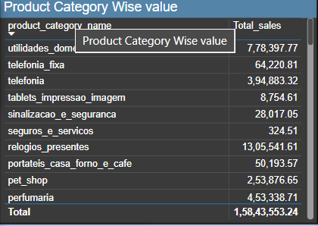

**Q.2** Determine the number of delayed orders in each category. An order is considered delayed if the actual delivery date is later than the estimated delivery date.

**Delayed Orders Analysis:-**

**Key Insight:**

The category with the highest number of delayed orders is "automotivo", with 328 delayed orders, followed by "bebes" with *198 delayed orders.

**Visualization:**

A table displaying the count of delayed orders for each product category helps identify problematic categories.

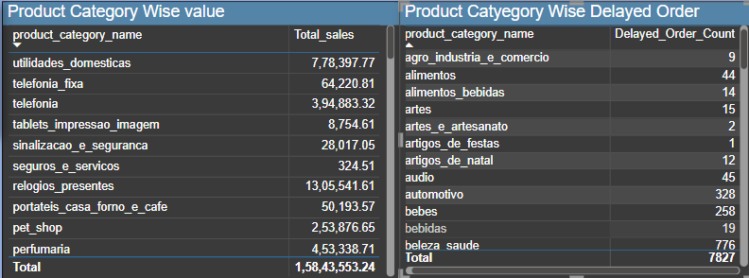

**Q.3.** Create a dynamic visual that compares the number of delayed orders to the number of orders received earlier for each month. Utilize the drillthrough cross-report feature to provide a detailed analysis of late and on-time deliveries.

**Monthly Comparison of Delayed and On-Time Orders:-**

**Key Insight:**

On-time orders far outnumber delayed orders across all months. However, delayed orders show a consistent trend, peaking during March and April.

**Visualization:**

A combined bar chart displays delayed versus on-time orders for each month.

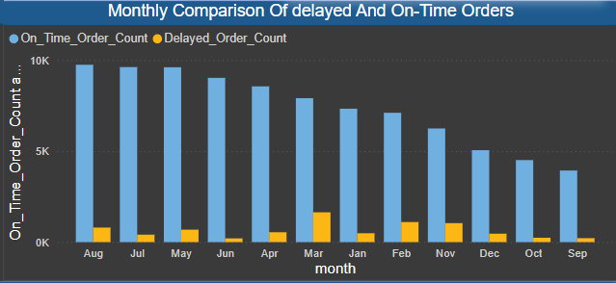

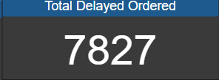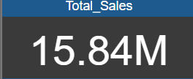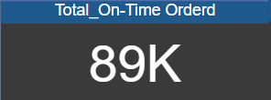

**Q.4.**  Analyze the most frequently used payment methods by customers using a visually appealing representation, such as a pie chart or other suitable visuals.

**Payment Method Analysis:-**

**Key Insight:**

The majority of transactions (75.24%) are made using credit cards, followed by boleto (19.46%). Other methods like voucher and debit card have significantly lower usage.

**Visualization:**

A pie chart is used to show the distribution of payment methods effectively.

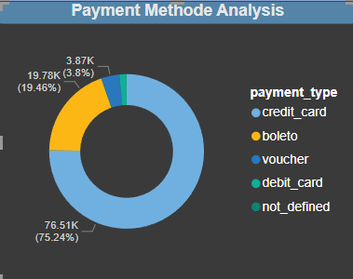

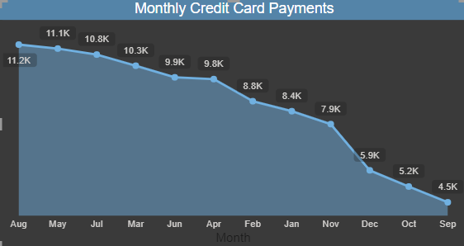

**Q.5.** Determine the top 10 highest-rated products and the bottom 10 lowest-rated products using a bar or column chart.

**Product Rating Analysis: -**

**Key Insight:**

The top-rated product category is "cama_mesa_banho", with a rating count of 10K, followed by "beleza_saude" at 9.1K.The lowest-rated product is "moveis_colchao_e_estofados", with a rating count of 41, followed by "flores" at 29**.**

**Visualization: -**

A bar chart displays the top 10 highest-rated and bottom 10 lowest-rated products.

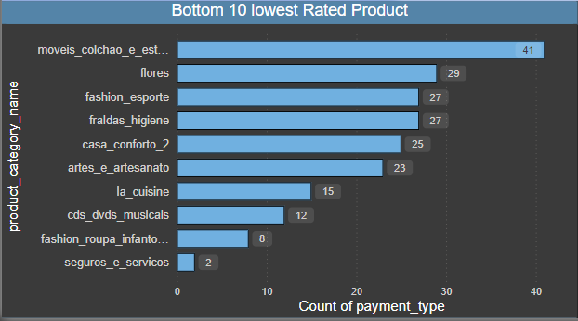

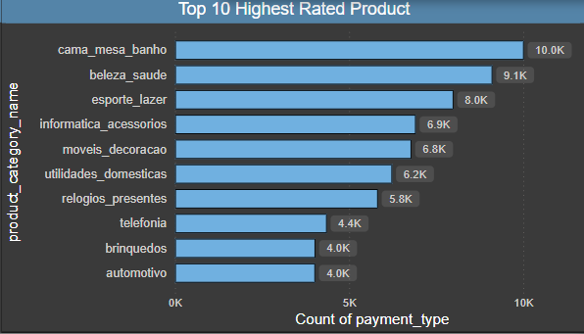

**Q.6.** Identify and visually represent states with high and low sales, providing a clear understanding of regional sales performance.

**State-wise Sales Analysis:-**

**Key Insight:**

Sales are concentrated in key regions such as Sao Paulo, with lower performance in less populated or rural states.

**Visualization**: A geolocation map provides a state-wise representation of sales performance.

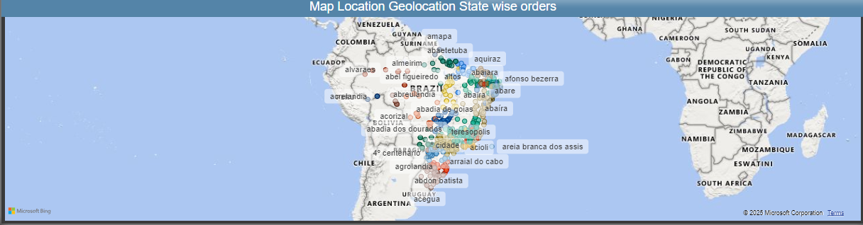

**Q.7.** Investigate and visualize any seasonal patterns (Quarterly) or trends in sales data over the course of the year.

**Seasonal Sales Patterns:-**

**Key Insight:**

Sales data indicates an upward trend during Q2 and Q3 of each year, particularly peaking in Q2 2017 with 15.21M in payment value.

**Visualization:** A line chart and quarterly breakdown highlight seasonal sales variations.

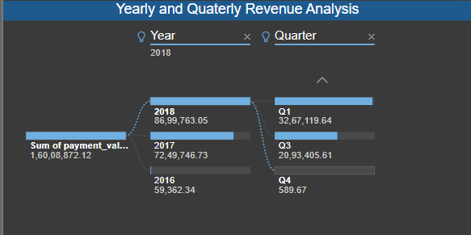

**Q.8.** Determine the total revenue generated by ShopNest Store and analyze how it changes over time(Yearly). Represent this information through suitable visuals to highlight trends and patterns.

**Revenue Analysis:**

**Key Insight:**

Total revenue generated over the analyzed period is 15.84M.

Yearly trends show consistent growth, with 2018 achieving the highest revenue of 86.99M compared to 2017 and 2016**.**

**Visualization:** A line chart showing annual and quarterly trends effectively illustrates the revenue growth.

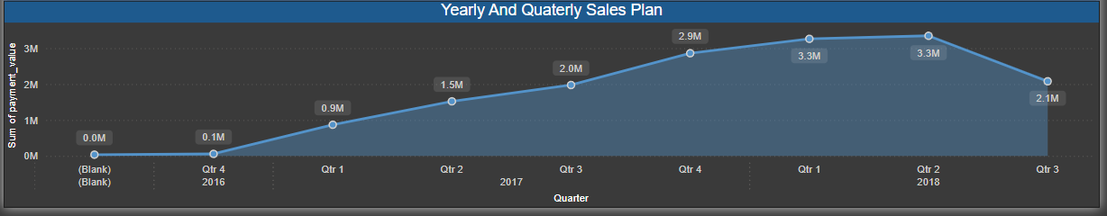

**Conclusion :-**

The analysis identifies key areas for growth and improvement:

* Enhance delivery efficiency for categories with a high count of delayed orders.
* Promote alternative payment methods to reduce reliance on credit cards.
* Focus on improving the performance and ratings of underperforming product categories.
* Leverage seasonal sales patterns to optimize marketing and inventory strategies during peak seasons.
* These insights can guide strategic decisions to maximize sales and customer satisfaction for ShopNest Store.